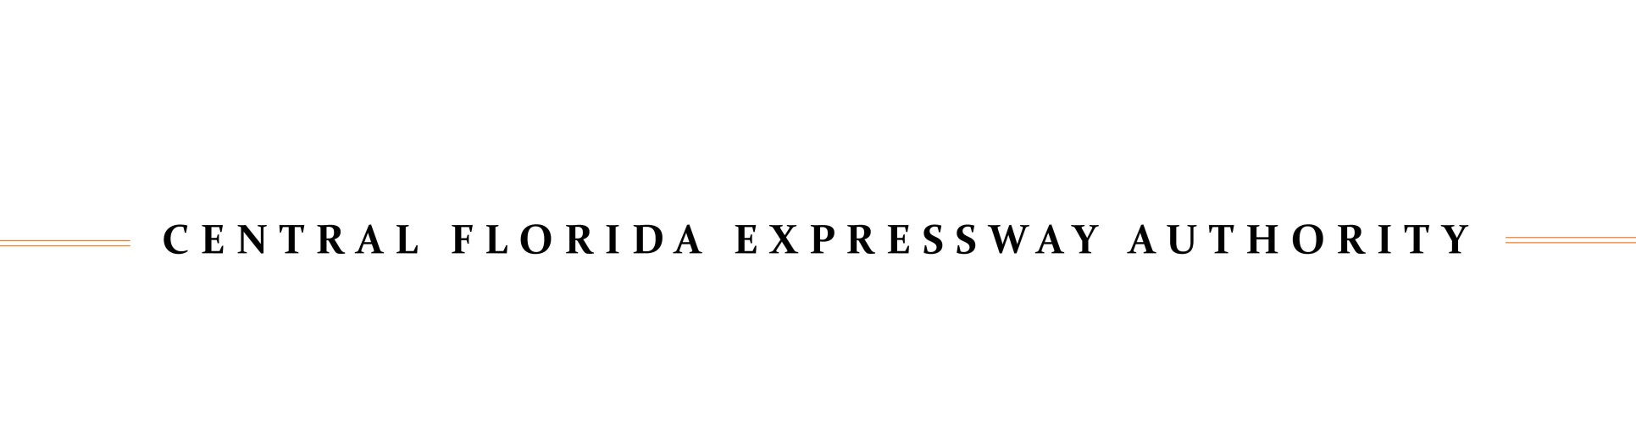

**MEETING NOTICE**

**Right of Way Committee Meeting**

# DATE: August 28, 2024 (rescheduled from 8/21)

# 

TIME: 2:00 p.m.

LOCATION: Central Florida Expressway Authority

4974 ORL Tower Road

Orlando, FL 32807

Pelican Conference Room

Section 286.0105, Florida Statutes states that if a person decides to appeal any decision made by a board, agency, or commission with respect to any matter considered at a meeting or hearing, they will need a record of the proceedings, and that, for such purpose, they may need to ensure that a verbatim record of the proceedings is made, which record includes the testimony and evidence upon which the appeal is to be based.

Any written public comments that are to be submitted to the Right-of-Way Committee, shall be emailed to [ROWComments@cfxway.com](mailto:ROWComments@cfxway.com) and must be received at least 48 hours before the start of the meeting, during regular business hours, to be included as part of the record. All comments will be distributed to Committee Members but only comments related to Committee items being voted upon will be included in the record. Please indicate the agenda item number related to your comments in your email subject heading.

Persons who require translation services, which are provided at no cost, should contact CFX at (407) 690-5000 x5316 or by email at [Malaya.Bryan@CFXWay.com](mailto:Malaya.Bryan@CFXWay.com) at least three (3) business days prior to the event.

In accordance with the Americans with Disabilities Act (ADA), if any person with a disability as defined by the ADA needs special accommodations to participate in this proceeding, then they should contact the Central Florida Expressway Authority at (407) 690-5000 no later than two (2) business days prior to the proceeding.

Posted 6/16/2024 at the CFX Administration Building